Title: **RSLogix 500 Pro Setup** Handout: 3

Course: Introduction to Automation Unit: Introduction to PLC CLO: 4

Name ____________________________ Station _______ Date ______________

**Objectives**

1. Student shall complete the setup of RSLogix 500 Pro
2. Student shall create a template file to use as a starting point for each Shop Job.

**Instructions**

Open RSLogix 500 Pro.

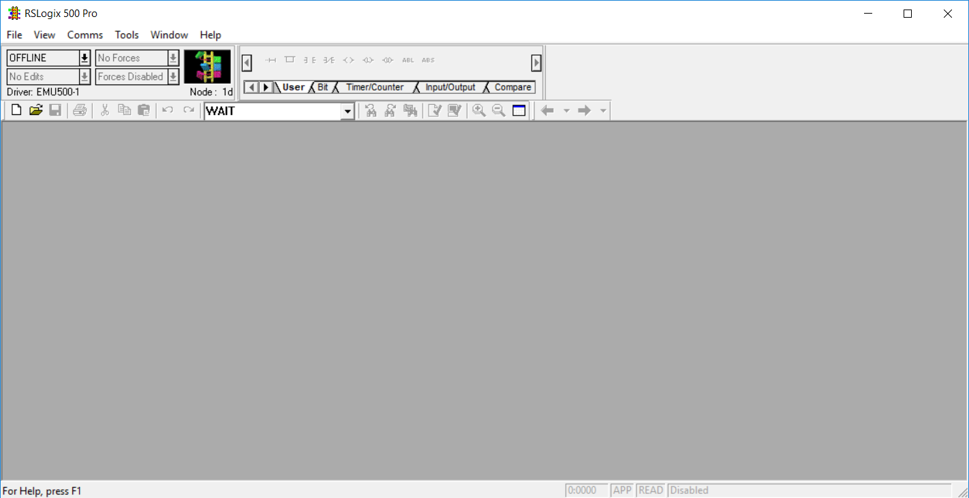

Select File > New

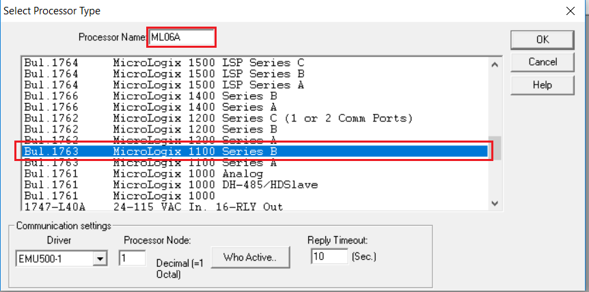

Enter a *Processor Name* (i.e. ML {your station number and letter})

Select *MicroLogix 1100 Series B*

Select the LAD 2 Window

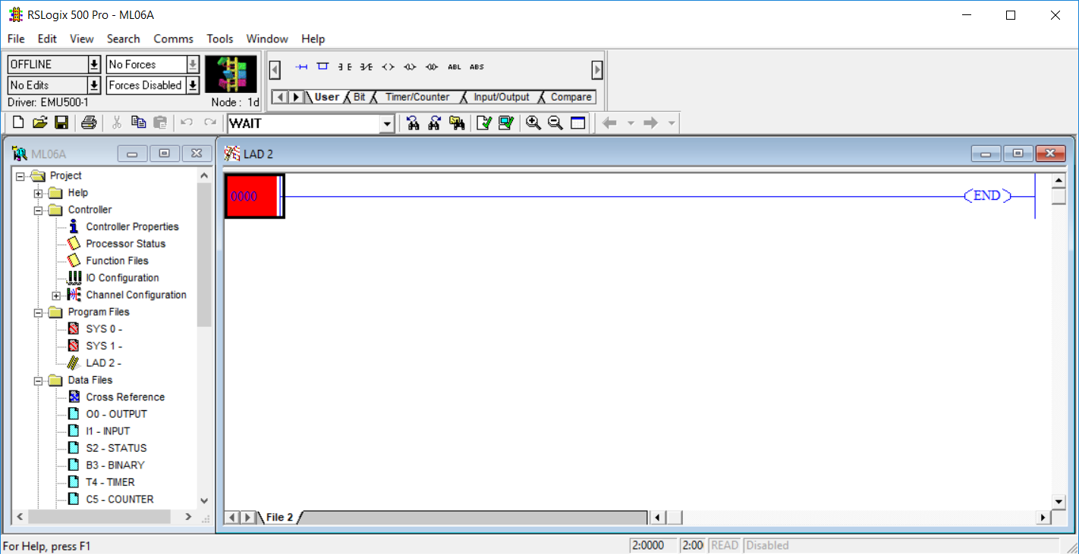

Select View > Properties

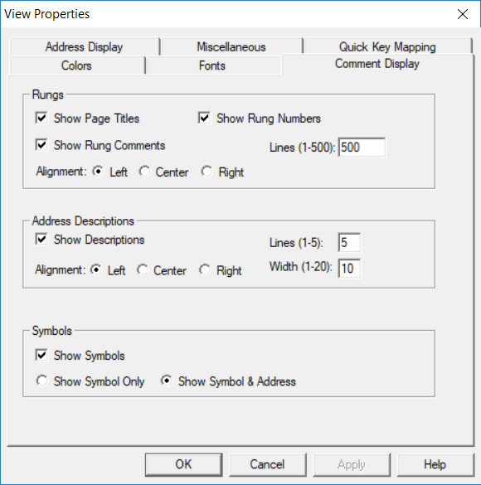

Under *Address Descriptions* change *Width* to 10. Select the *Miscellaneous* Tab

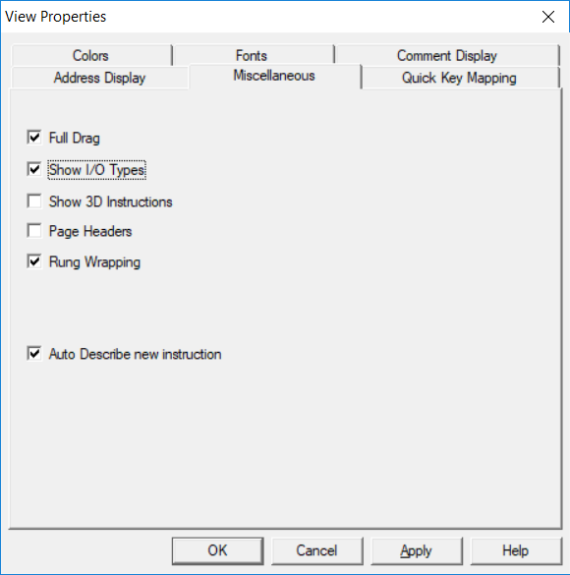

Uncheck *Show I/O Types*

Select *File > Report Options*. Select *Ladder Setup*

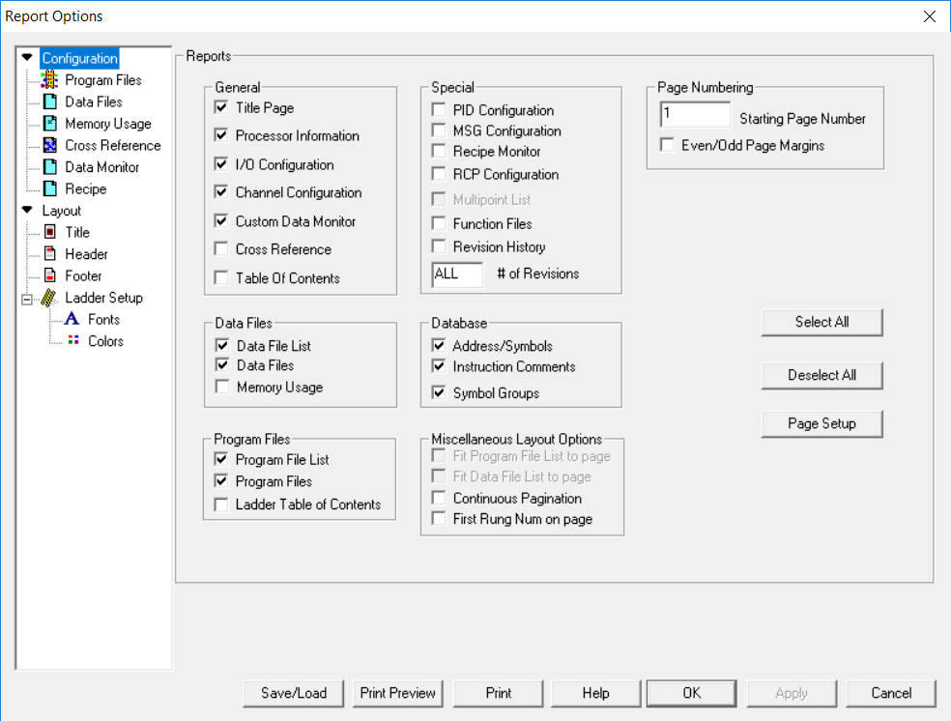

Uncheck *Show I/O Types*

